Online Payment Process
- Login to the ERP by providing user name and password. User name format is XXXX@DAVCSP, where XXXX is the admission number of the student, for example if a student has admission number as 11459 than the user name to login is : 11459@DAVCSP. The Password is by default –password.
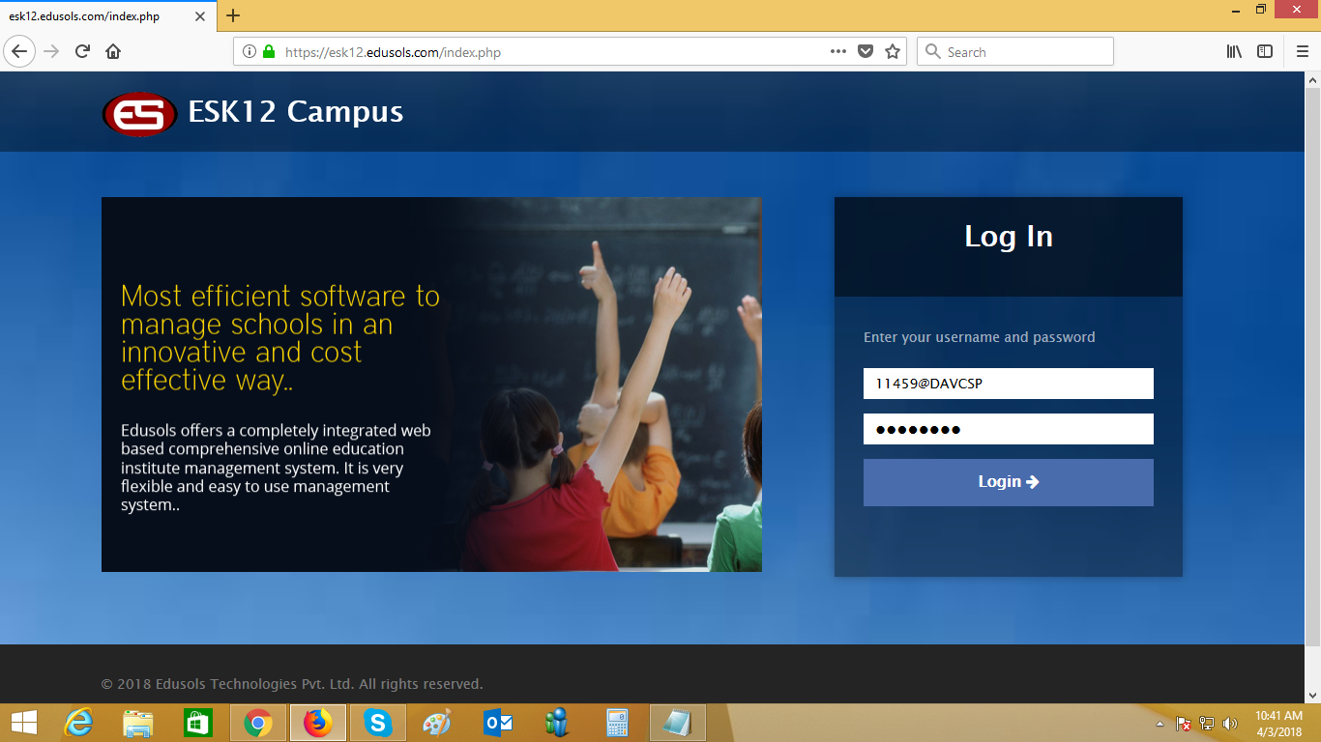

2] After login the student name is displayed .Click on the “Proceed “ button to login to the current session displayed.
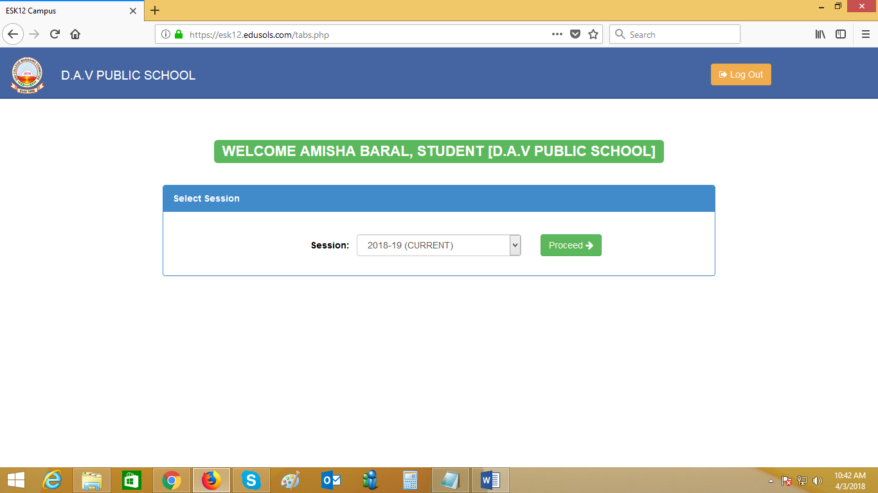
3] You can change your password or Logout of the screen by clicking on the photo icon displayed on the upper right hand corner of the screen.
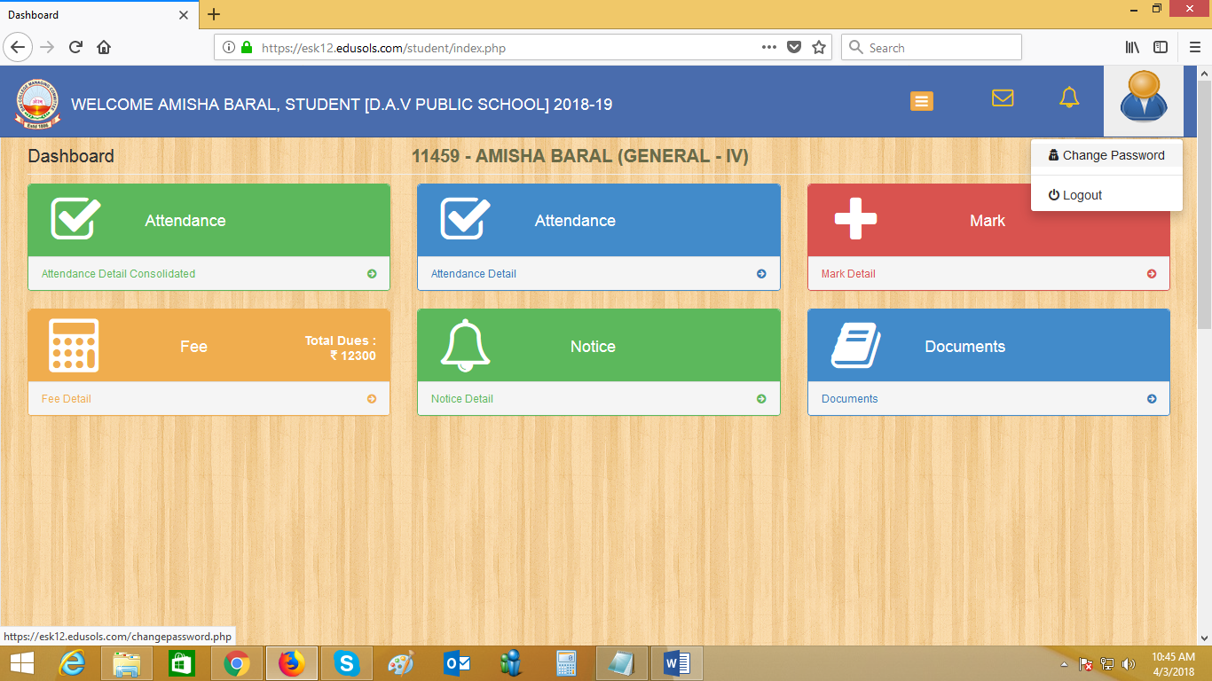

4] Move the mouse pointer over the Fee template displayed. Two buttons will be visible as “FEE DETAIL”, and “PAY”. Click on the “PAY” button to view total due for payment.
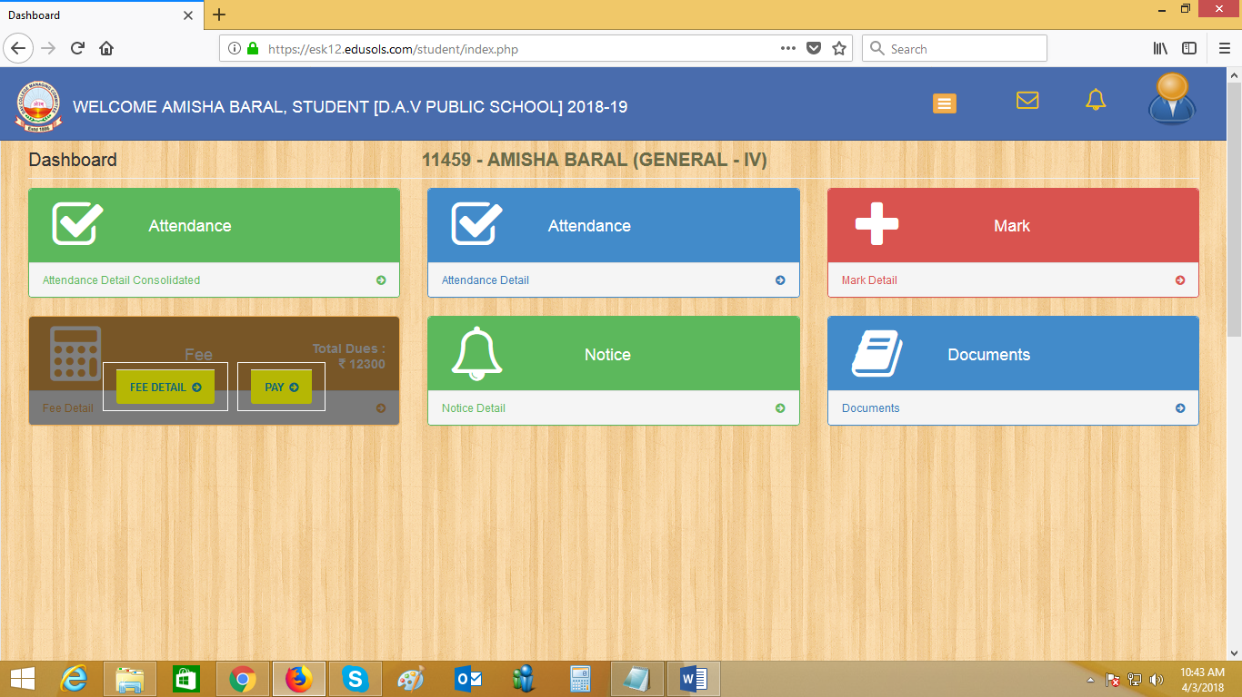
5] Click on the Online Payment button to go to the Payment Gateway screen.
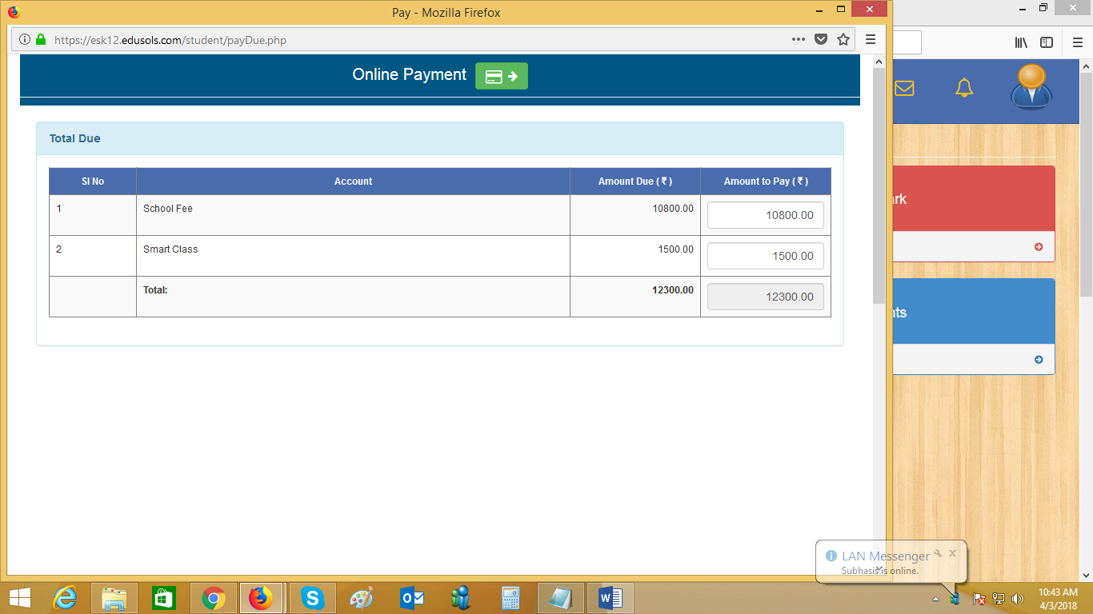

6] Select the payment gateway and Click on the “Pay Now” button for payment. Follow the instruction given by the Payment Gateway.
